
The University of Azad Jammu & Kashmir
Name | Rizwan Ali
Roll No | 2025-SET-40
Lab No | 04
Instructor | Sir Fahad Nisar
Course | Software Configuration and Management Technologies

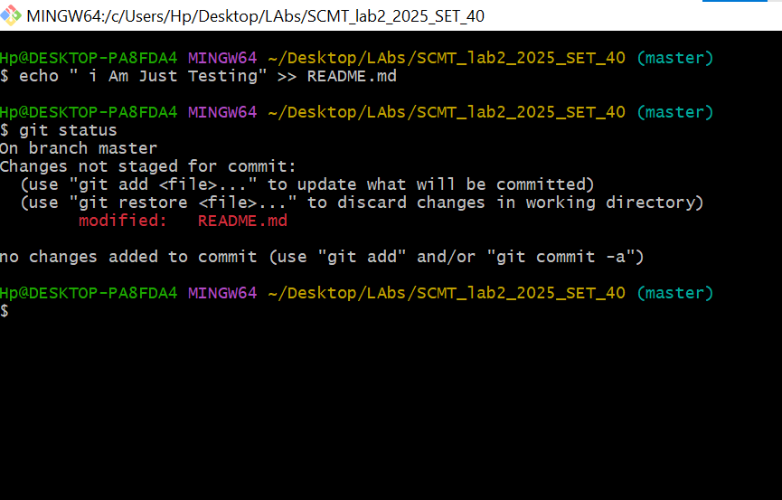
1.Verifying Uncommitted changes :-
2.Shelving Work Temporarily (Git Stash)
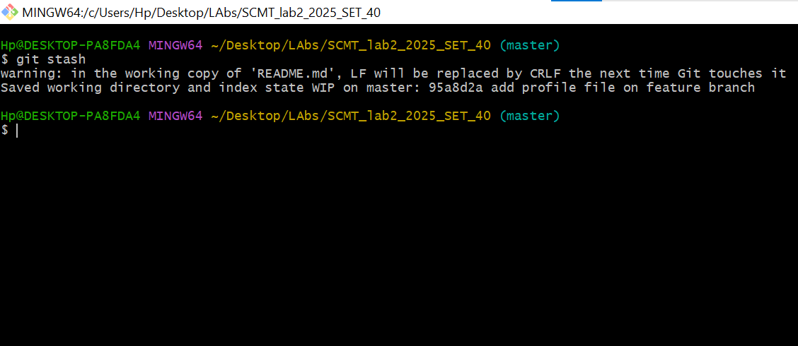

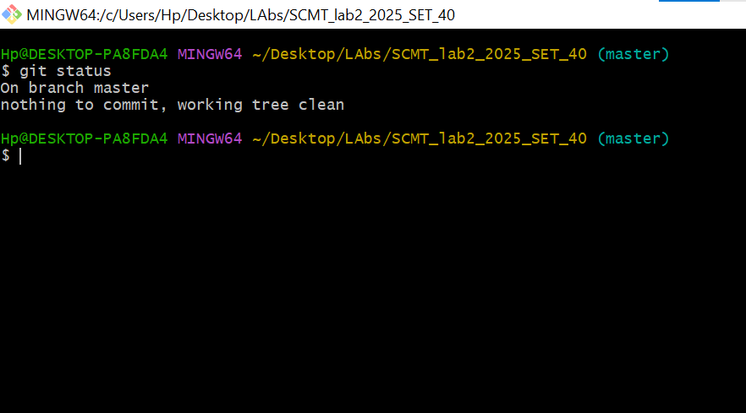

3. Viewing The stash List

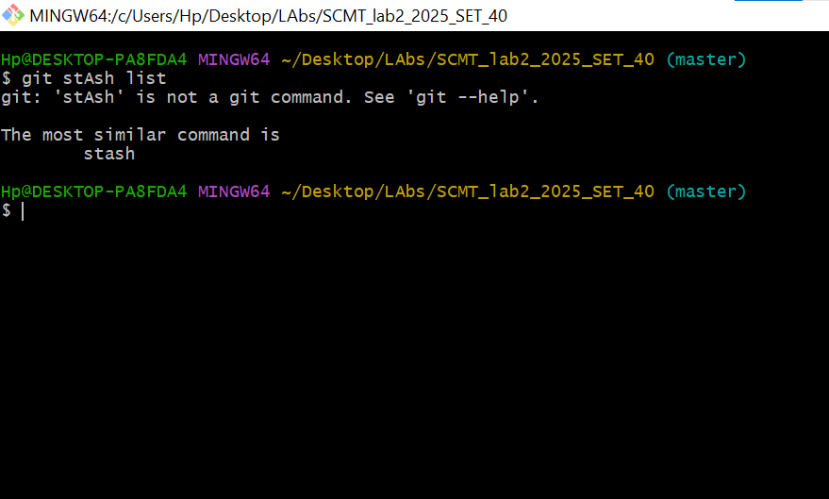
4. Git Stash Pop (Restoring Stashed changes)

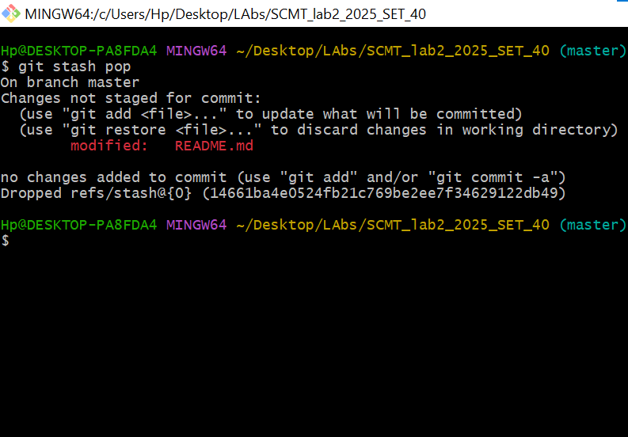

5.Staging & Committing The File , Git Reset Soft
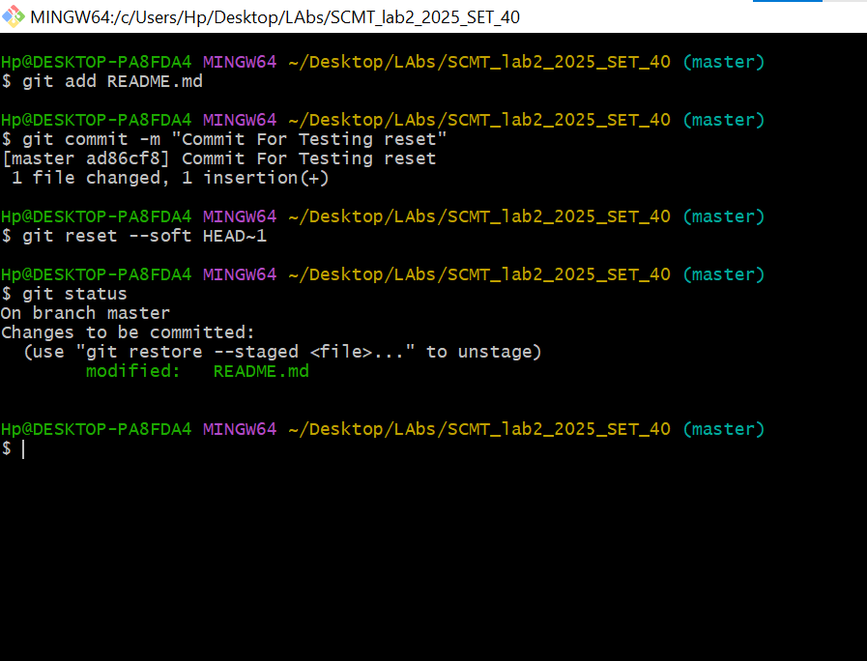

6. Recommitting With New Message
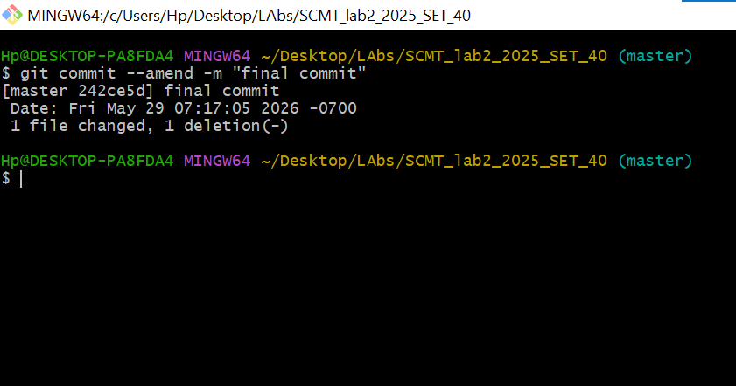

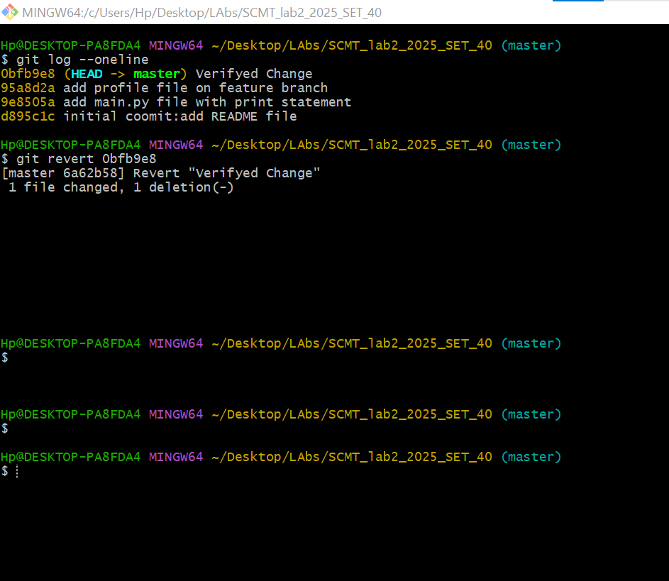
7. Viewing Commit log, Fetching Hash & git Revert


8. Verifying Final Commit History Log

9. Modifying Last Commit
